SOFTWARE TESTING LABORATORY MANUAL
Experiment 1: Test Plan and Test Strategy Document

Aim: To prepare a Test Plan and a Test Strategy document for the sample web application — PDFMaker (PDF Generator).
Software / Tools Required: MS Word / Google Docs, PDFMaker application (React + Vite + TypeScript frontend, Rust axum + genpdf backend), Chrome/Firefox browser.

Theory
A Test Strategy is a high-level, organization- or project-wide document that describes the overall testing approach: what levels of testing will be done (unit, integration, system, acceptance), what types of testing are in scope (functional, performance, security), and general standards to be followed. It usually does not change often and is not tied to one release.
A Test Plan is a project-specific document, usually written by the Test Lead, that describes what will be tested, how, by whom, and when, for a particular release or module. It is derived from the Test Strategy and the requirements of the specific application under test.
Key difference: Strategy = "how we test, in general" (macro level); Plan = "how we test this release" (micro level, one document per project/release).

Procedure
- Study the requirements of the sample application (PDFMaker: enter title + content + optional image, click Generate PDF, download document.pdf).
- Identify the scope of testing — features to be tested and features not to be tested.
- List the testing types applicable (functional, usability, compatibility, security, regression).
- Identify test levels, test environment, entry criteria and exit criteria.
- Identify roles and responsibilities of the testing team.
- Prepare the Test Strategy document first (organization-level), then the Test Plan (project-level) using the tables below.

Sample Application — Brief Requirements (PDFMaker)
PDFMaker is a simple web app that generates PDF documents from a title, body text, and an optional image.
Architecture: Frontend (frontend/) — React + Vite + TypeScript UI where users enter a title, content, and optionally upload an image. Backend (backend/) — Rust (axum + genpdf) server that renders the PDF and returns it as a downloadable file.
- Frontend form: Title (text input, required, placeholder "Enter document title"), Content (textarea, required, 10 rows, placeholder "Write your PDF content..."), Image (optional file input, accept image/*, with live preview), Generate PDF button (shows "Generating..." while loading), success/error message line.
- Backend API: POST http://localhost:3000/api/generate/pdf with JSON {title, content, image_base64 (raw base64 or data URL, optional)}. Returns application/pdf with Content-Disposition attachment; filename="document.pdf". Uses bundled Liberation fonts, 15pt margins, centered title, centered image, then content paragraph.
- Flow: Frontend sends POST /api/generate/pdf → backend builds PDF with genpdf crate → frontend downloads blob as document.pdf. CORS configured for http://localhost:5173. Backend listens on http://localhost:3000, frontend dev server on http://localhost:5173.

Table 1: Test Strategy for PDFMaker Application
Test Strategy ID: TS-PDFM-001. Static, organization-level approach applied to the PDFMaker release.
Section | Content
1. Testing Objective | Ensure the PDFMaker web application works correctly as per functional requirements (title + content + optional image → valid downloadable PDF) and provides a simple, usable experience.
2. Testing Levels | Unit Testing — individual functions (title/content state, image FileReader, generatePdf fetch, backend generate_pdf, image decode). System Testing — complete app (frontend + backend + PDF download) as a system. User Acceptance Testing (UAT) — verify app meets user requirements (PDF contains entered title/content/image).
3. Testing Types | Functional — title/content validation, image upload + preview, Generate PDF, PDF download, success/error messages. Usability — form labels, placeholders, preview, button states, message readability. Security — CORS (only localhost:5173 POST), large/invalid base64 handling, invalid image rejection. Compatibility — Chrome / Firefox on Windows. Regression — re-verify existing features after any change.
4. Test Environment | Windows OS; Chrome + Firefox; Frontend: React + Vite dev server on http://localhost:5173; Backend: Rust axum server on http://localhost:3000 (cargo run); bundled Liberation fonts; test images (PNG/JPG, valid + corrupt).
5. Entry Criteria | All project files available (frontend/src/App.tsx, backend/src/main.rs, fonts); backend builds (cargo build passes) and runs on port 3000; frontend runs on port 5173; test data and sample images available.
6. Exit Criteria | All major test cases executed; no open Critical/High defects; title/content/image → PDF flow works; PDF opens and shows correct title, content and image; test results recorded and reviewed.
7. Roles & Responsibilities | Test Lead — planning, strategy/plan review and sign-off. Testers — test case design, execution and defect reporting. Developer — defect fixing and retest support.
8. Risks & Mitigation | Backend port 3000 occupied → free port / kill process. CORS failure → verify CorsLayer origin http://localhost:5173. Invalid/corrupt image base64 → app must show "Error generating PDF" without crash. Large content/image → verify PDF still renders. Fonts missing → bundle liberationSans folder with backend.
9. Deliverables | Test Strategy document, Test Plan document, Test Cases, Defect Reports, Test Execution Results, Test Summary Report.
10. Tools & Standards | Manual testing in browser + curl/Postman for POST /api/generate/pdf; PDF validation by opening document.pdf; IEEE 829-style documentation.

Table 2: Test Plan for PDFMaker Application (IEEE 829-style, simplified)
Derived from TS-PDFM-001 for this release of PDFMaker.
Section | Content
Test Plan ID | TP-PDFM-001
Objective | Verify title input, content textarea, optional image upload with preview, Generate PDF button, POST /api/generate/pdf integration, and document.pdf download work as per requirements.
Scope — In | Title field (required validation), Content field (required validation), Image upload (optional, preview), Generate PDF button + loading state, Backend PDF generation (title centering, image embedding, content paragraph), Success message "PDF generated successfully!" / error message "Error generating PDF.", Chrome + Firefox verification.
Scope — Out | Payment gateway, user authentication/login, mobile native app, PDF editing after download — not implemented in current version.
Test Levels | Unit testing (by developers: form handlers, generate_pdf), System testing (frontend + backend end-to-end), User Acceptance Testing (PDF content matches input).
Test Types | Functional, Usability, Compatibility (Chrome/Firefox), Security (CORS, invalid base64/image handling), Regression.
Entry Criteria | Frontend deployed on localhost:5173; backend deployed on localhost:3000; cargo build + npm run dev succeed; test data (sample titles, contents, valid/invalid images) available.
Exit Criteria | 95% test cases executed; no open Critical/High defects; core flow (title + content → PDF download; title + content + image → PDF with image) works; test summary report signed off.
Environment | Windows 11, Chrome / Firefox, frontend http://localhost:5173 (React+Vite+TS), backend http://localhost:3000 (Rust axum + genpdf + Liberation fonts), sample PNG/JPG images.
Roles | Test Lead — planning & review; Testers — test case design & execution; Developer — defect fixes and retest builds.
Schedule | Test design: 2 days; Test execution: 3 days (functional 1.5d, usability/compatibility/security 1d, retest 0.5d); Regression: 1 day.
Risks | Backend not starting (port conflict, missing fonts); frontend-backend CORS mismatch; corrupt image upload crashing render; network failure during fetch; large PDF generation timeout.
Deliverables | Test cases, Defect reports, Test execution report (incl. generated document.pdf evidence), Test summary report.

Conclusion
The Test Strategy defines the general testing approach for the PDFMaker application, while the project-specific Test Plan (TP-PDFM-001) details what will be tested in this release. Executing these against the working build (verified: backend POST /api/generate/pdf returns HTTP 200 application/pdf, frontend loads on port 5173) ensures the title/content/image → PDF workflow is functionally correct, usable and regression-safe.

Screenshots of Working Project
Fig 1: PDFMaker — PDF Generator working UI (http://localhost:5173) with Title, Content, Image (optional) and Generate PDF button. Verified working: backend http://localhost:3000 returns document.pdf on POST /api/generate/pdf.
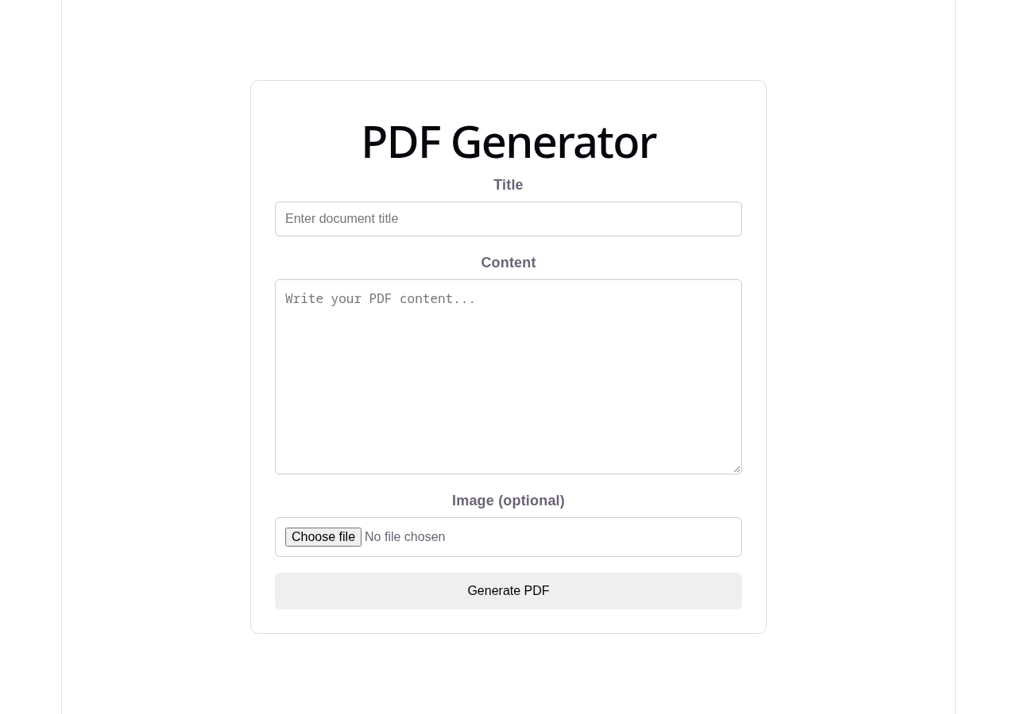
Fig 2: Entering details in PDFMaker — Title ("SweetDelights Bakery - Product Catalog"), Content and optional Image selected (sample_upload.png with live preview) before clicking Generate PDF.
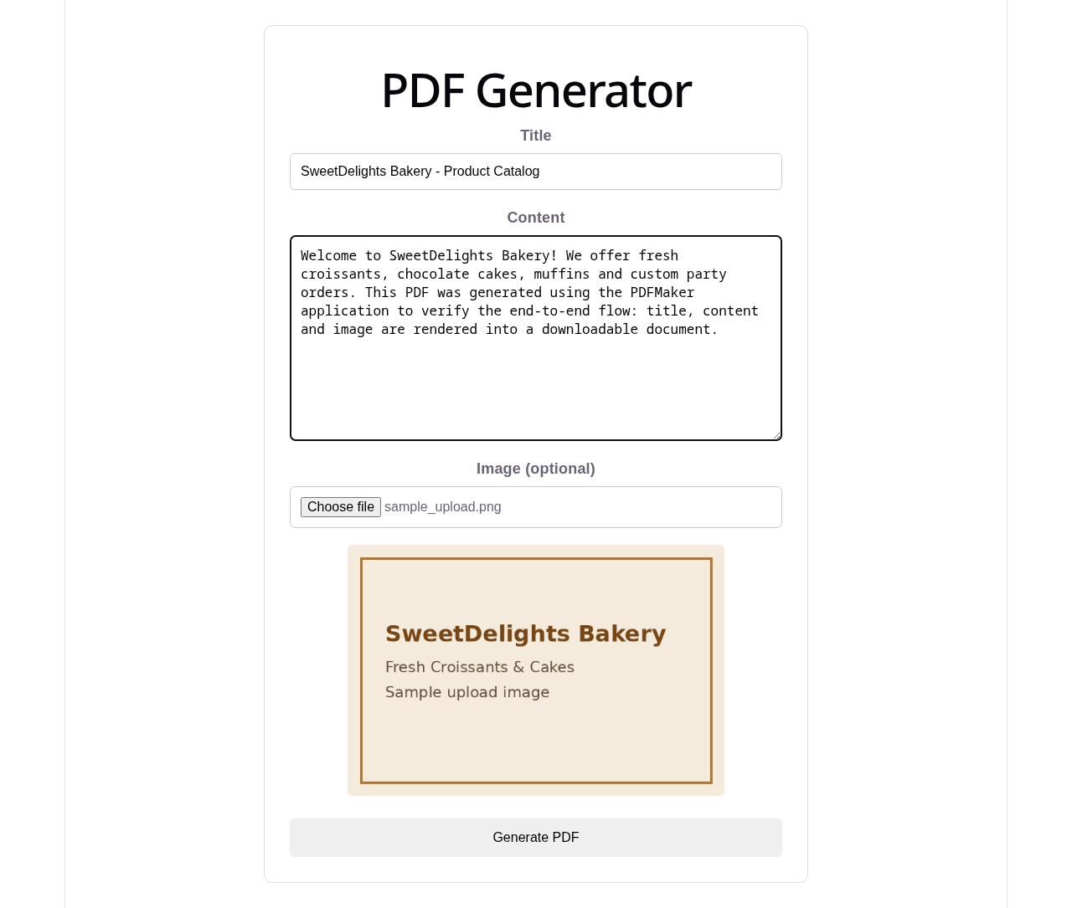
Fig 3: Generated PDF output (document.pdf) — rendered with centered title, embedded image and content paragraph. The file downloaded automatically with success message "PDF generated successfully!" on the UI.


